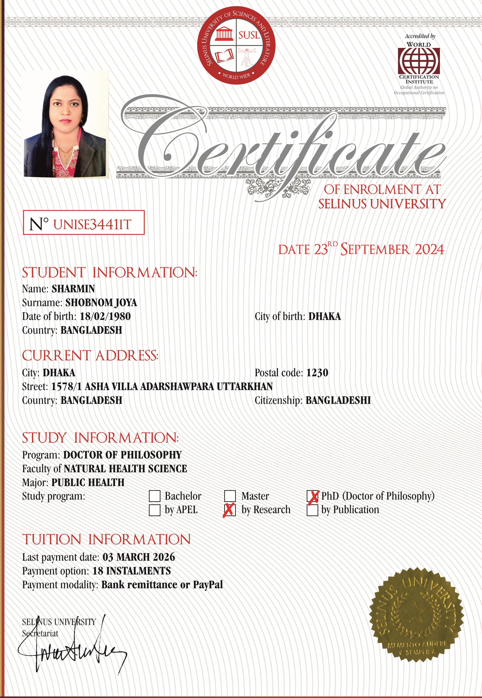
SELINUS UNIVERSITY

